**Que 1) Plot a histogram,**

**10, 13, 18, 22, 27, 32, 38, 40, 45, 51, 56, 57, 88, 90, 92, 94, 99**

Ans. Taking Bins = 10

**Que 2) In a quant test of the CAT Exam, the population standard deviation is known to be 100. A sample of 25 tests taken has a mean of 520. Construct an 80% CI about the mean.**

Ans) Here 𝜎 =100, n= 25**,** μ= 520,Confidence Interval = 80%

Significance value= 1- C.I = 1-0.80 = 0.20

Point Estimate +- Margin of error

X̄ +- Z α/2

Z 0.20/2 = z 0.10

1-0.10 = 0.9 which is 1.29 as per Z-table

Lower fence = X̄ - α/ 2𝜎 /√n

= 520- 1.29 100**/**√25 = 520 – 1.29 100/5

= 520 – 1.29*20 = 520 – 25.8

= 494.2

Higher Fence = X̄ + α/2𝜎/√n

**=** 520 + 1.29 100/√25 = 520 + 1.29 100/5

= 520 + 1.29*20 = 520 +25.8

= 545.8

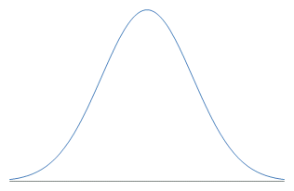

**494.2**  **545.8**

Conclusion: So with 80% C.I the range is between 494.8 as lower fence & 545.8 as higher fence. Accept null hypothesis between this or else reject it.

**Que 3) A car believes that the percentage of citizens in city ABC that owns a vehicle is 60% or less. A sales manager disagrees with this. He conducted a hypothesis testing surveying 250 residents & found that 170 residents responded yes to owning a vehicle.**

1. **State the null & alternate hypothesis.**
2. **At a 10% significance level, is there enough evidence to support the idea that vehicle owner in ABC city is 60% or less.**

Ans) Step 1: Null hypothesis H0: P0: 60%

Alternate hypothesis H1: P0 ≠ 60%

Here n = 250, X̄ = 170, p̂ = x/n = 170/250= 0.68

q0 = 1-p0 = 1-0.6 = 0.4

Step 2: α = 1-0.90 = 0.10/2 = 0.05 = 0.95 As per Z-table 1.65 is 0.9505.

Step 3: If the range will be between the given limit than accept null hypothesis or else reject it.



**-1.65**  **+1.65 0.05**

**Accept Null hypothesis Reject null hypothesis**

**Accept Null hypothesis**

**+1.65**

Step 4: Z-test with proportion formula p̂ - p0 = 0.68-0.60 = 0.08 = 0.08 = 0.08

√p0q0/n √0.6*0.4/250 √0.24/250 √0.00096 0.03098

= **2.5823**

As 2.5823 > 1.65 so Reject Null hypothesis.

Conclusion: There is no enough evidence to support the idea that vehicle ownership In city ABC is 60%

or less.

**Que 4) What is the value of the 99 percentile?**

2,2,3,4,5,5,5,6,7,8,8,8,8,8,9,9,10,11,11,12

Ans) Formula Percentile*n+1 = 99*20+1 = 0.9*21 = 18.9th index

100 100

Average of 18th & 19th index 11+11/2 = 11. So 11 is the datapoint at 99 percentile.

**Que 5) In left & right-skewed data, what is the relationship between mean, median & mode?**

**Draw the graph to represent the same.**

Ans)

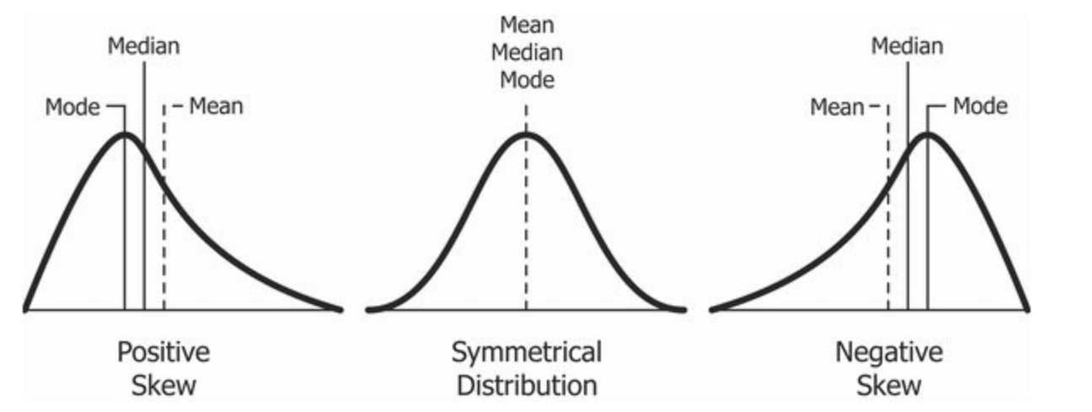

Eg : 1) Wealth distribution Eg : 1) Age of people Eg : 1) Life span of humans.

2) Length of comments In you tube video 2) Weight of people